**System Testing**

**Digital Voting System**

1. **Testing**

Testing is the process of finding or test the error and bugs into the system before the system release. It is performed by QA (Quality Assurance) team’s that evaluates how the system performance and system components are work actually correct and match to the related condition. It estimates that all the requirements are meet properly.

* 1. **Black Box Testing**

Black Box Testing is the testing approach that avoid the internal part (coding) of a system and only focuses on the what exactly output created in response to certain input cases. This testing methods inspect the functionality of the system.

**Black Box Tests the following functions:**

* Syntax error and performance error
* Incorrect and missing fields
* Error in database and structure of it
* Input and output of the cases

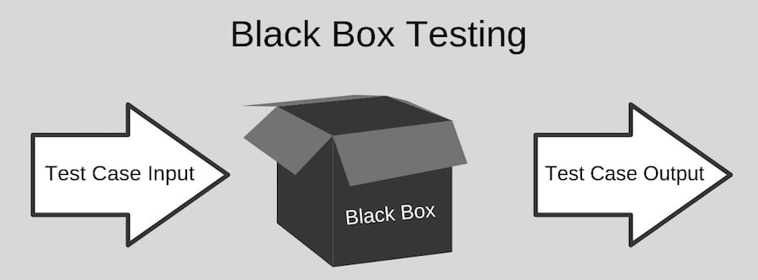

Figure 1 black box testing image

* 1. **White Box Testing**

White Box Testing is the testing approach that is test the internal working process or coding part of the system. This testing is the flow of working processes and verify it for the system.

**White Box Test the following cases:**

* Data flow of inputs through the coding
* Expected output through coding
* Internal poorly structural process and security break points

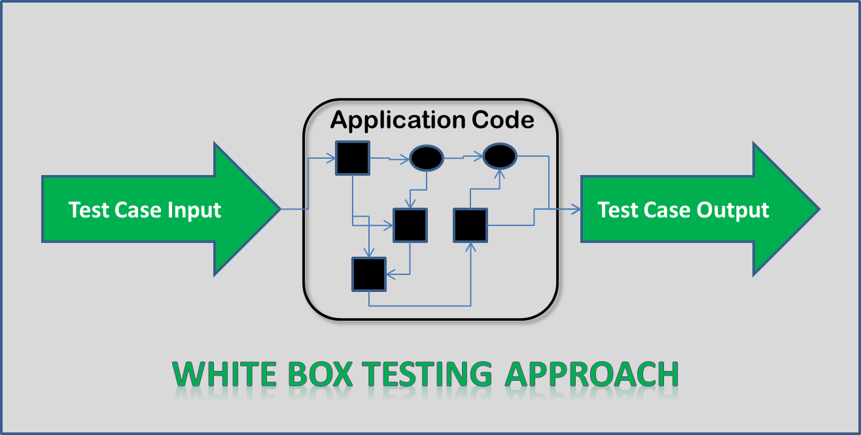

Figure 2 white box testing

**Test Cases: Black Box Testings**

|  |  |
| --- | --- |
| **Test Case:** | 1 |
| **Test Name:** | Voter Login Test |
| **Test Data:** | [Dipakgupta463@gmail.com](mailto:Dipakgupta463@gmail.com), dipakdipak |
| **Purpose of test:** | To verify email and password then go to dashboard |
| **Expected output:** | Login and go to dashboard |
| **Actual output** | Successfully logged-in and open a dashboard |
| **Result** | Pass |

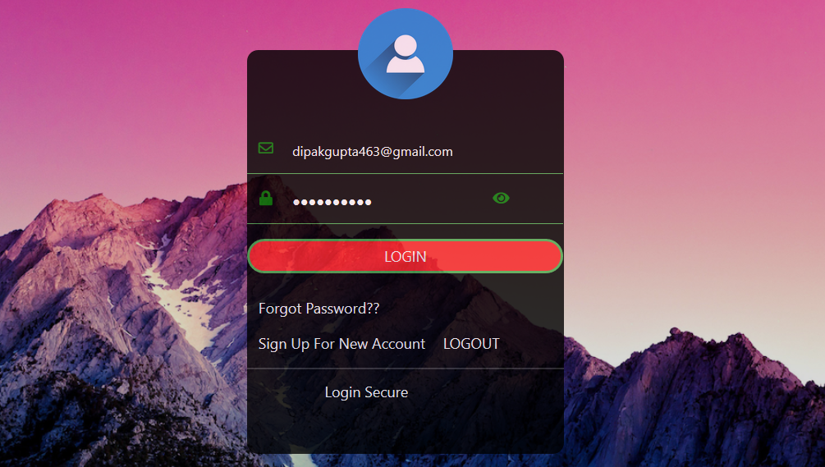

Figure 3 black box testing of voter login

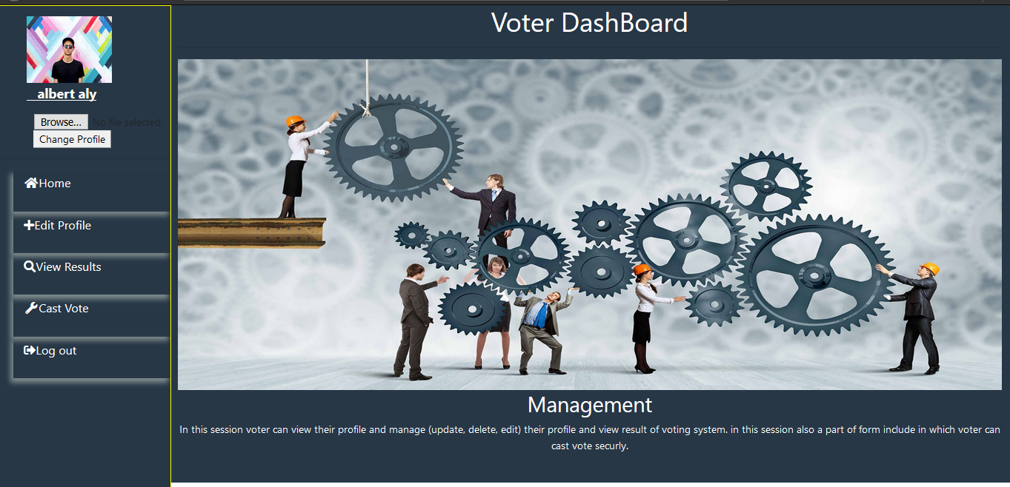

Figure 4 Dashboard after voter login success

|  |  |
| --- | --- |
| **Test case:** | 2 |
| **Test Name:** | Voter Registration |
| **Test Data** | Sita, lama, Kathmandu, 12-12-1999, female, 19872347653, [sita@gmail.com](mailto:sita@gmail.com), sitasita |
| **Purpose of Test:** | Account Register for login to the system |
| **Expected output** | Account register and redirect into login page with success message |
| **Actual output** | Successfully registered account and redirect into login page |
| **Result** | Pass |

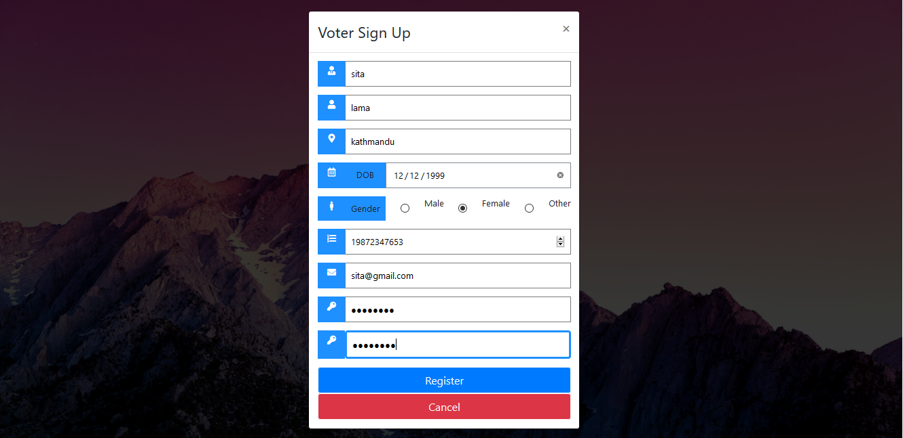

Figure 5 black box testing of voter registration account

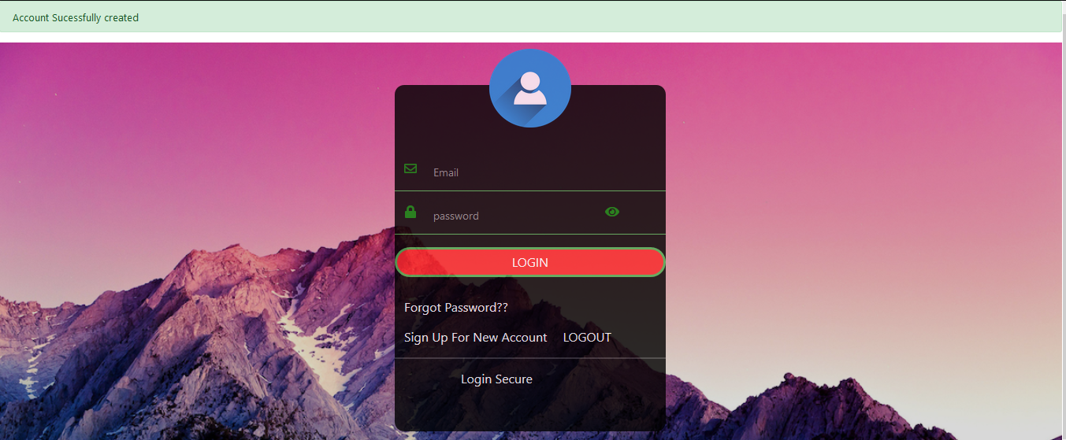

Figure 6 successfully register and redirect into login page

|  |  |
| --- | --- |
| Test Case: | 3 |
| Test Name: | Candidate Login |
| Test Data: | [rahul@gmail.com](mailto:rahul@gmail.com), rahuls |
| Propose of Test: | To verify email and password then go to candidate dashboard |
| Excepted output: | Login and go to candidate dashboard |
| Actual output: | Successfully logged-in and then open a candidate dashboard |
| Result: | Pass |

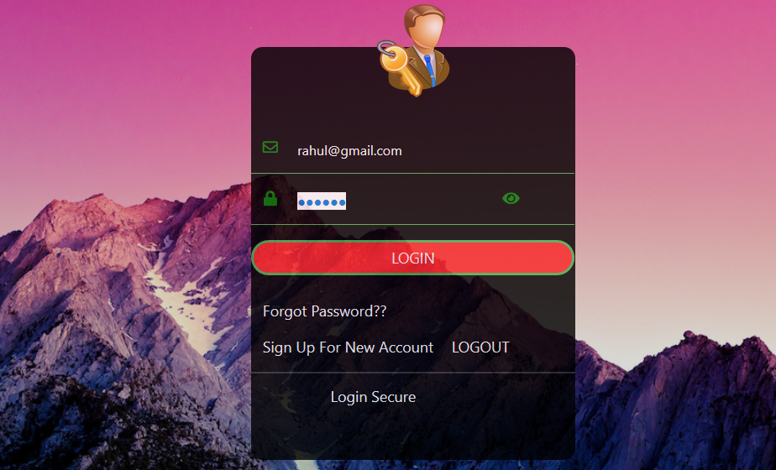

Figure 7 black box testing of candidate login

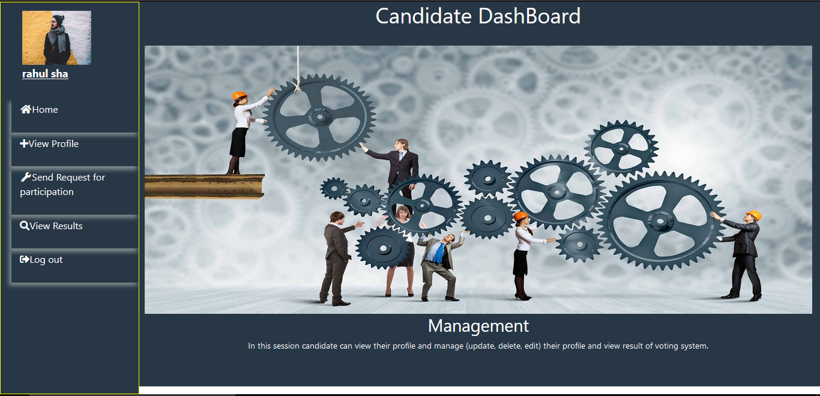

Figure 8 successfully logged in and open a dashboard of Rahul

|  |  |
| --- | --- |
| **Test case:** | 4 |
| **Test Name:** | Candidate Registration |
| **Test Data** | Hari, Thapa, Pokhara, 9779812446612, 12-12-1980, Male, [hari@gmail.com](mailto:hari@gmail.com), 12398778901, harihari |
| **Purpose of Test:** | Account Register for login into the system |
| **Expected output** | Account Register and redirect into login page with success message. |
| **Actual output** | Successfully created account and redirect into login page with successfully message |
| **Result** | Pass |

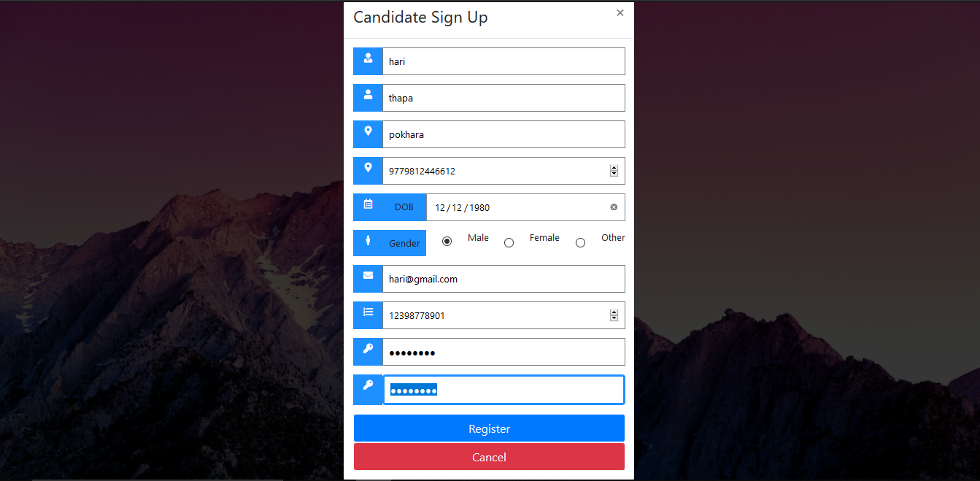

Figure 9 black box testing of candidate registration

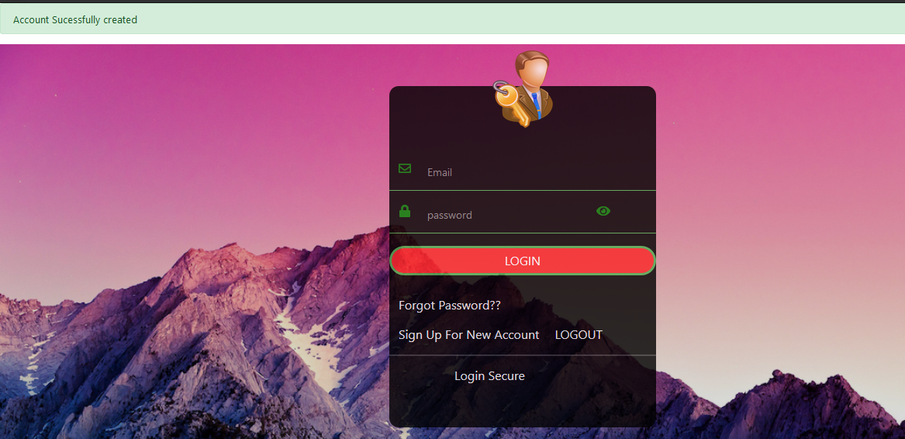

Figure 10 Successfully message and redirect into login page after registration

|  |  |
| --- | --- |
| **Test Case:** | 5 |
| **Test Name:** | Add Blogs by admin |
| **Test Data:** | Rules about voting, image, content, 12-07-2019 |
| **Propose of Test:** | To check whether there is right content post |
| **Excepted output:** | Post blogs and display in blog page in home page |
| **Actual output:** | Successfully added blogs and display in blog page |
| **Result:** | Pass |

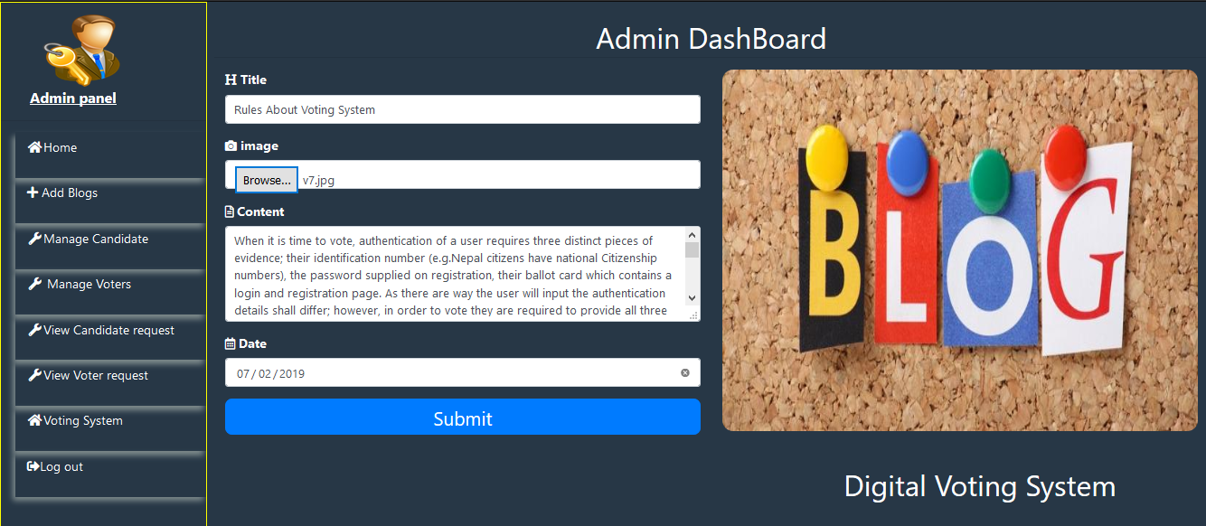

Figure 11 black box testing of add blogs by admin

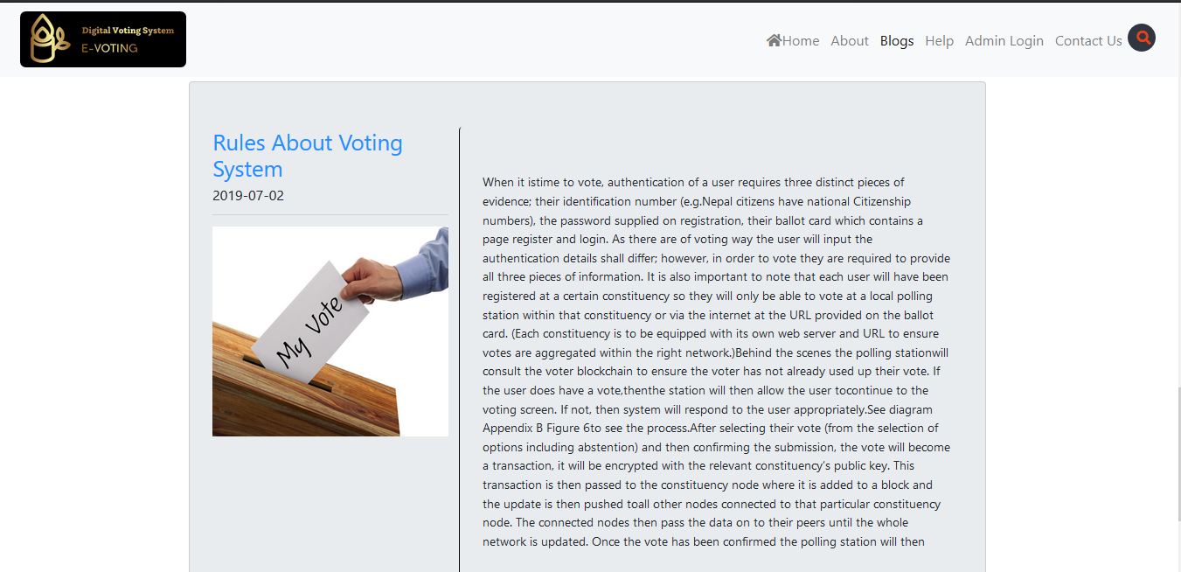

Figure 12 display blogs in blogs page posted by admin

|  |  |
| --- | --- |
| **Test Case:** | 6 |
| **Test Name:** | Add Candidate by admin |
| **Test Data:** | Dipak Shah, Nepal communist party, party symbol, candidate photo |
| **Propose of Test:** | Add candidate for election |
| **Expected output:** | Candidate added and shown just below that form |
| **Actual output:** | Candidate added successfully and display below the form with delete button |
| **Result:** | Pass |

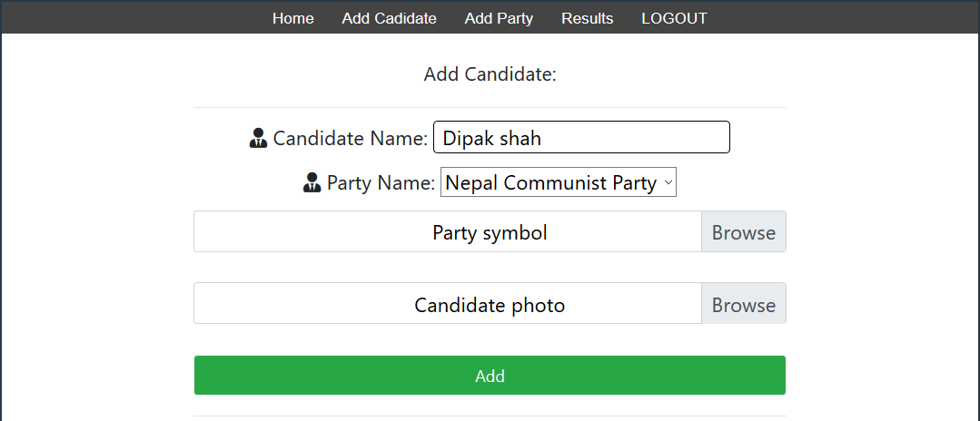

Figure 13 black box testing of candidate added by admin

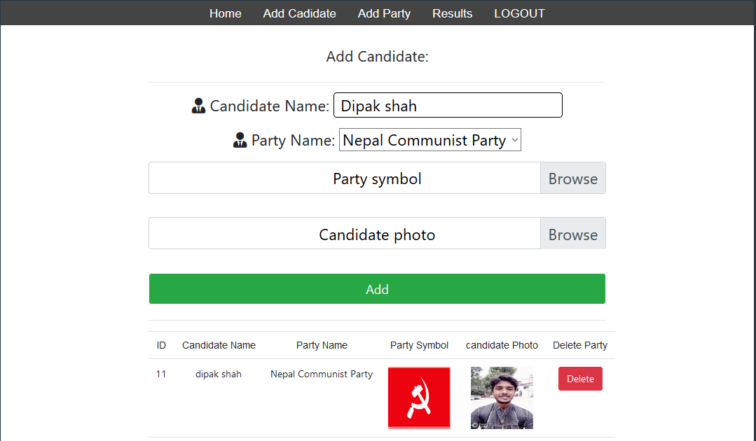

Figure 14 candidate added successfully and displayed into table

|  |  |
| --- | --- |
| **Test Case:** | 7 |
| **Test Name:** | Add party name by admin |
| **Test Data:** | Nepal communist party, party symbol |
| **Propose of Test:** | Add party for each candidate selected for election |
| **Expected output:** | Add party and display below the form party and use other form also |
| **Actual output:** | Party added successfully and display below the form |
| **Result:** | Pass |

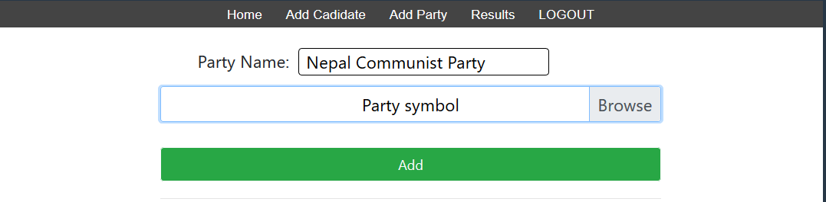

Figure 15black box testing of party added by admin

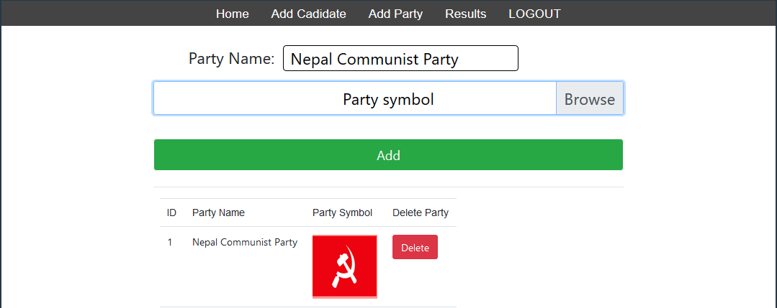

Figure 16 display party below the form

|  |  |
| --- | --- |
| **Test Case:** | 8 |
| **Test Name:** | Send request for participation in election |
| **Test Data:** | Lila, Gautam, bagmati, nepal, 9779845895332, 12-12-1981, female, [lila@gmail.com](mailto:lila@gmail.com), 10101098765, photo |
| **Propose of Test:** | Send request for participation in election |
| **Expected output:** | Send request and redirect into the request page with success message |
| **Actual output:** | Successfully send and redirect to request page with success message. |
| **Result:** | Pass |

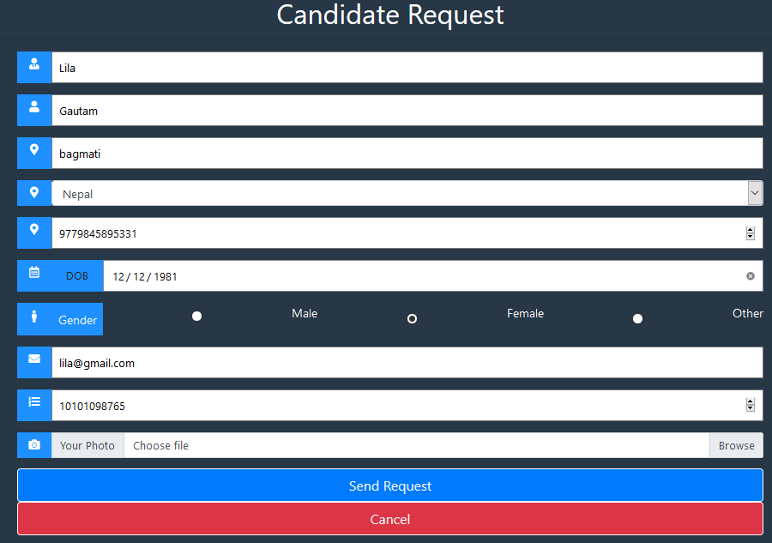

Figure 17 black box testing of send request of candidate

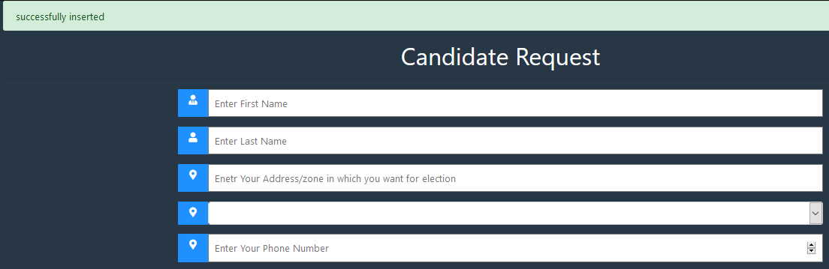

Figure send message shown

|  |  |
| --- | --- |
| **Test Case:** | 9 |
| **Test name:** | Voter id send by admin |
| **Test Data:** | Voter_id=20-----Voter_id=12345678901 |
| **Propose of Test:** | Send voter id then use it voter can vote |
| **Expected output:** | Send voter id to the voter |
| **Actual output:** | Successfully send voter id and redirect into voter request page with success message |
| **Result:** | Pass |

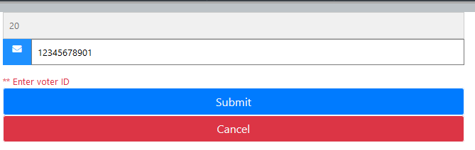

Figure 19 black box testing of sending voter id to the voter by admin

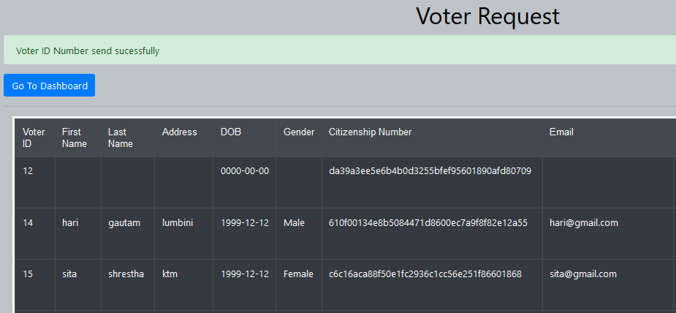

Figure 20 voter id send successfully message

|  |  |
| --- | --- |
| **Test Case:** | 10 |
| **Test Name:** | Admin login |
| **Test Data:** | [admin@gmail.com](mailto:admin@gmail.com), admin |
| **Propose of Test:** | To verify email and password and manage all system |
| **Expected output:** | Admin login and go to admin panel |
| **Actual output:** | Login success and go to admin panel |
| **Result:** | Pass |

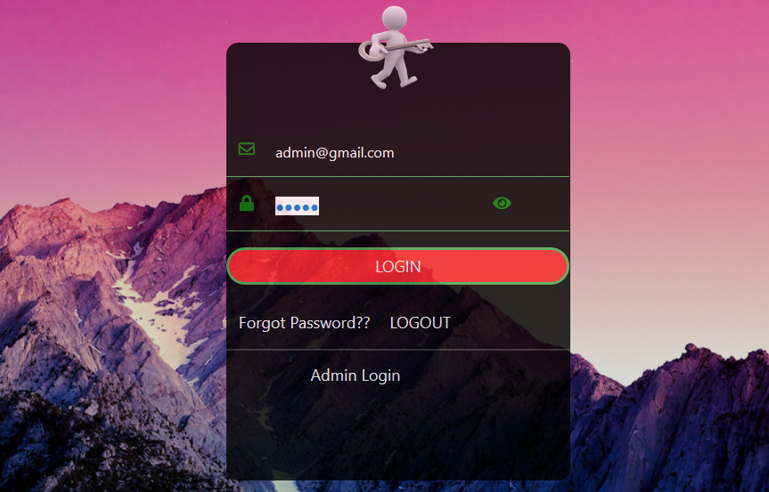

Figure 21 black box testing of admin login

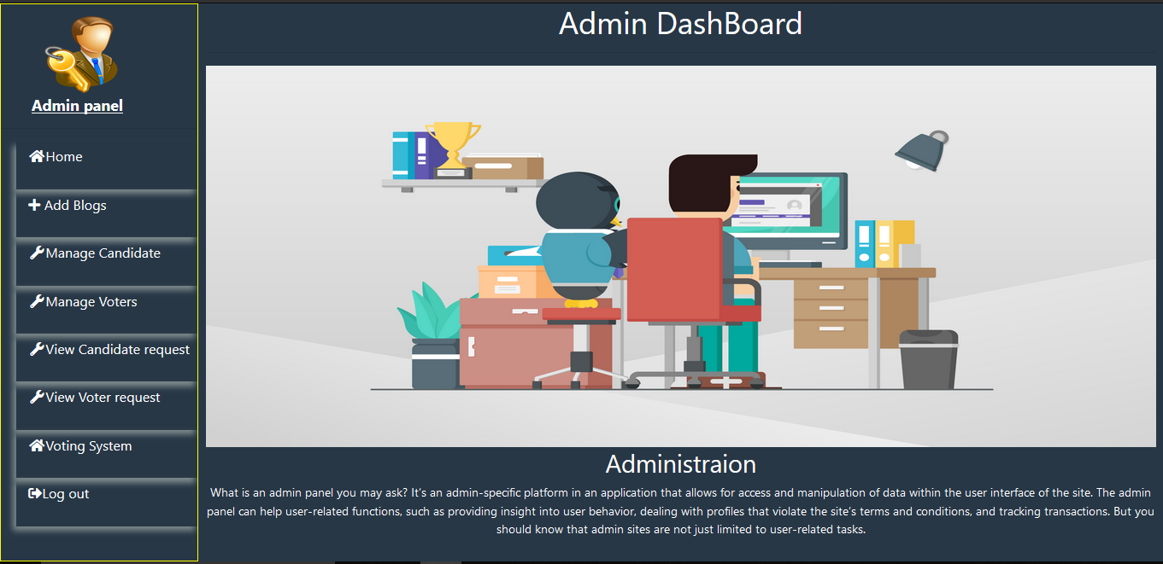

Figure 22 admin panel after successful login

|  |  |
| --- | --- |
| **Test Case:** | 11 |
| **Test Name:** | Management of Administration |
| **Test Data:** | Nicola, tesla, [nicola123@gmail.com](mailto:nicola123@gmail.com), nicola123 |
| **Propose of Test:** | Register for login into the system |
| **Expected output:** | Register success and redirect into register page |
| **Actual output:** | Successfully registered and redirect into register page with success message and display all admin below the table for manage |
| **Result:** | Pass |

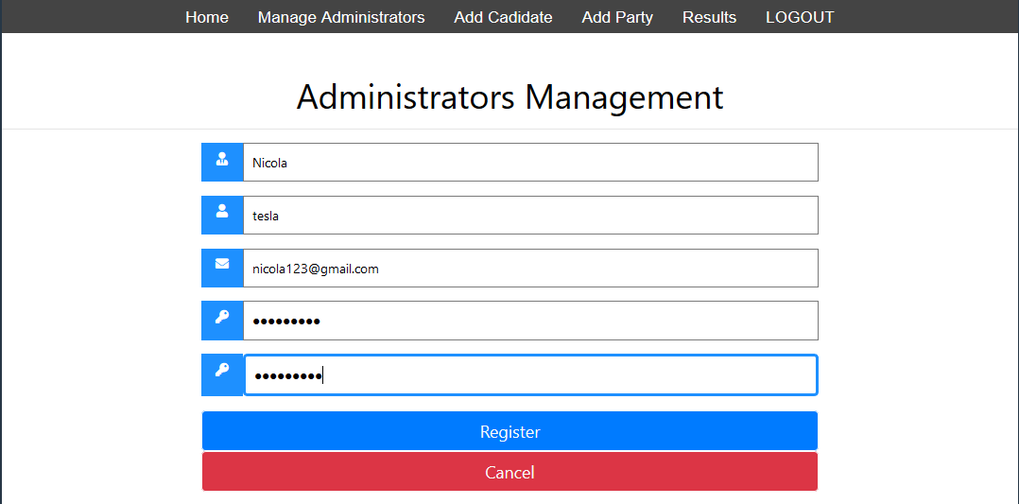

Figure 23 black box testing of new admin registration

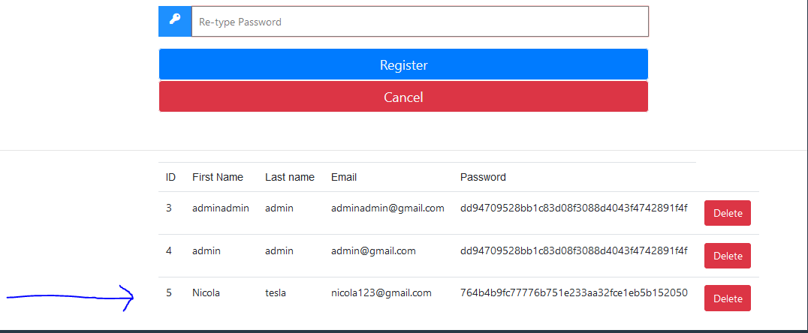

Figure 24 new admin added

* 1. **Unit Testing**

Unit testing is the technique of test in which test all the individual unit or components of the system. it includes one or few inputs and one outputs.

**Test 1: Voter Login**

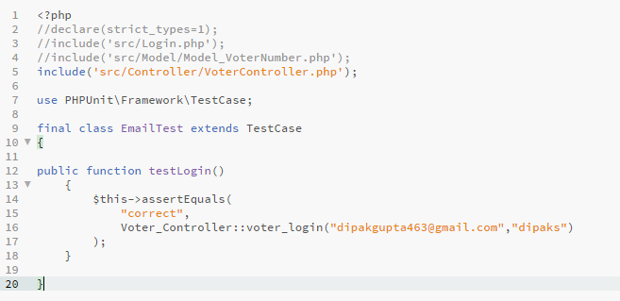

Figure 25 unit testing function of voter login

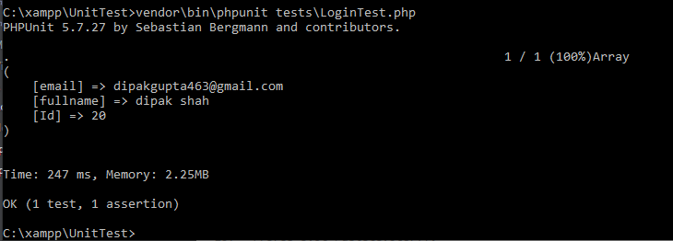

Figure 26 successfully tested result

**Test 2: Candidate Login**

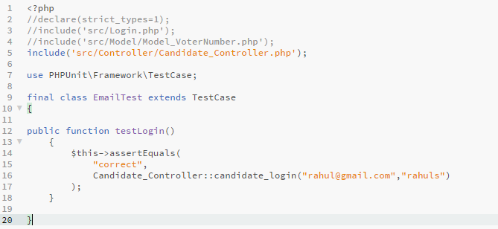

Figure 27 unit test of candidate login

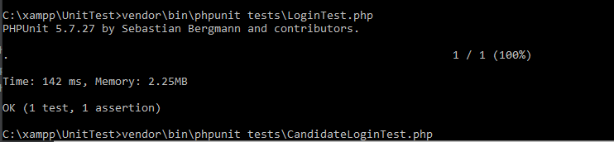

Figure 28 test result of candidate login

**Test 3: Voter Register**

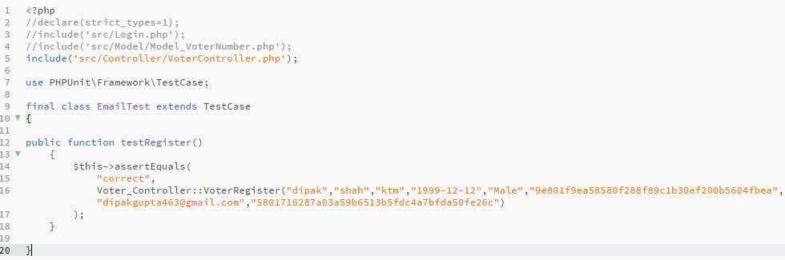

Figure 29 unit test function of voter Registration

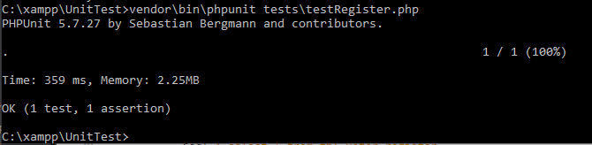

Figure 30 test result of voter registration

**Test 4: Failed while two tests in one class (voter register and candidate register).**

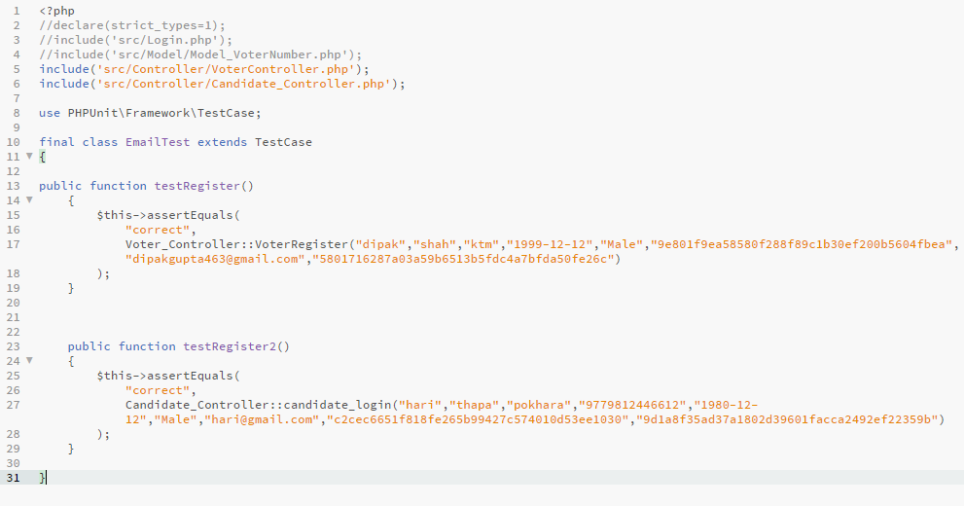

Figure 31 unit test failed while register test

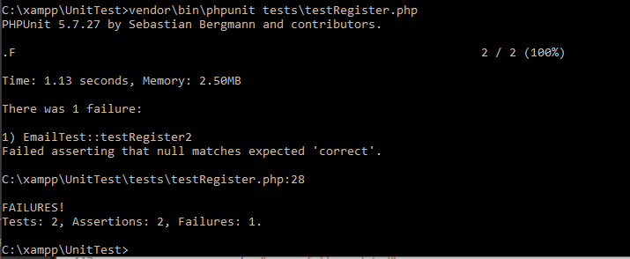

Figure 32 test failed result

**Test 5: Send voter Card Number**

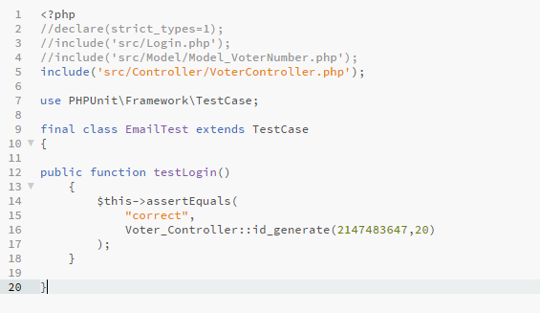

Figure 33 unit test function of send voter Id

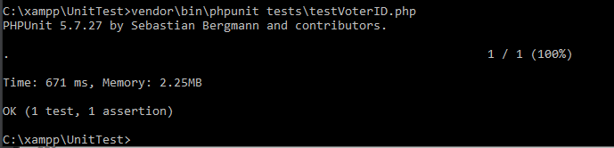

Figure 34 test result of sending voter id

**Test 6: Add candidate by admin**

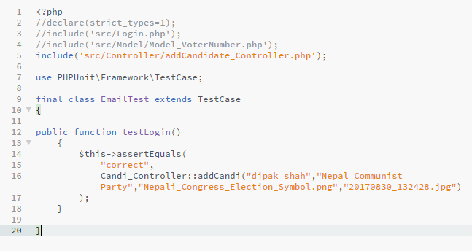

Figure 35 unit test of add candidates by admin

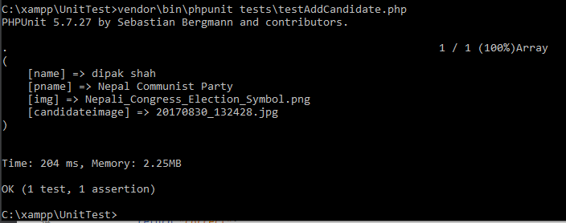

Figure 36 test result of add candidates

**Test 7: Add Party by admin**

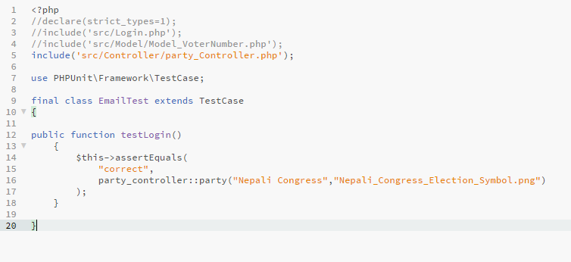

Figure 37 unit testing of add party

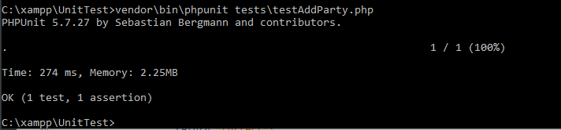

Figure 38 test result of add party

**Test 8: Add new administration**

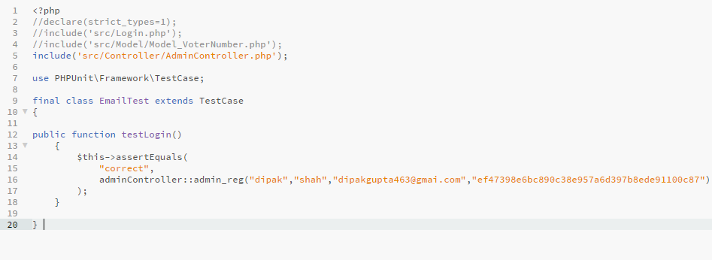

Figure 39 unit testing of admin registration

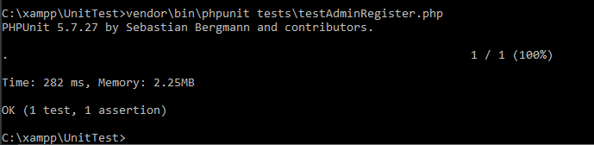

Figure 40 test result of adding new admin

**Test 9: Add Blogs By admin**

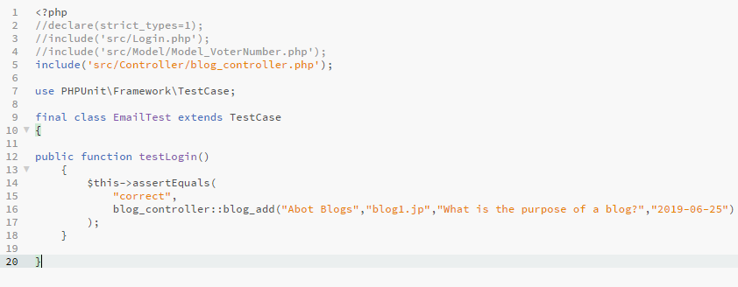

Figure 41 unit testing of add blogs

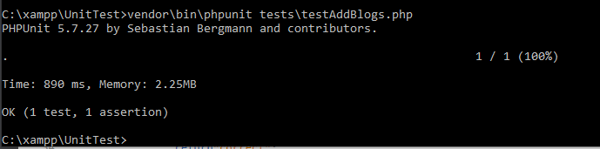

Figure 42 test result of adding blogs

**Test 10: Admin Login**

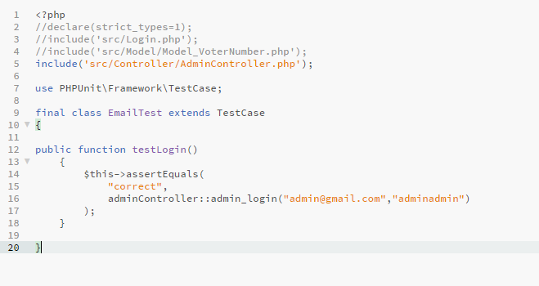

Figure 43 unit testing of admin login

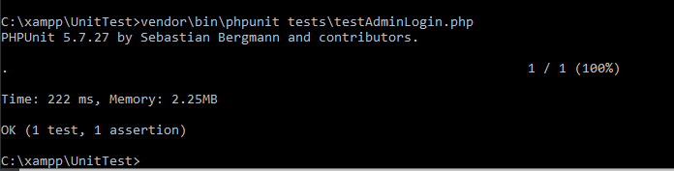

Figure 44 test result of admin login